**Execution Jumping and Branching**

The initial task screenshot:

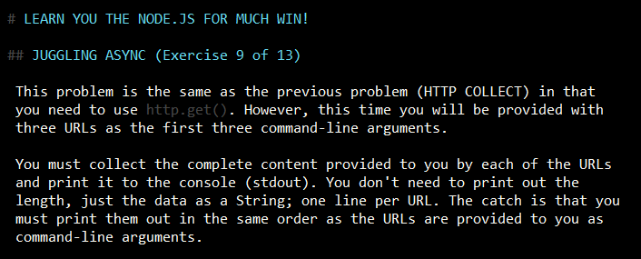

I solved the problem, but it seemed interesting to visualize the program execution time-flow, jumping around, and branching at the asynchronous methods. So I added some visualization and time-track-down features. It was also interesting to play with handling the time delay (getSeconds() and getMilliseconds(), lines # 27 – 35).

The output screenshot:

